**NAMES: NZAMBAZAMARIYA Delphine**

**REG NO: 21RP01628**

**EMAIL: nzambaphine2022@gmail.com**

**IPRC MUSANZE**

**ELECTRICAL AUTOMATION TECHNOLOGY**

**TOPIC: SMART HOME AUTOMATIC SYSTEM**

**PROJECT NAME :AUTOMATIC OPEN DOOR CONTROL WITH SERVO MOTOR CONTROLLED BY PIR SENSOR**

**INTRODUCTION**

Offers businesses and individuals alike the assistance they require to set up an integrated automatic door management system. By providing access control, security, data storage, and remote management all in one go, this type of system is a must for all businesses.

## What is an Automatic Door Opener?

An automatic door opener is an easy-access, simple-to-operate system for the doors of any type of business, industrial or commercial. Previously, ADA requirements for accessible design required the use of an automatic door system, however, it has increasingly become a measure of a customer-focused business

The PIR sensor in the project acts as a motion detector and detects the presence of humans in its field of vision. The PIR sensor provides this data to the**Raspberry Pi controller**, which then operates a DC motor in order to open the door. Two IR sensors are then used to find the number of people entering through the door.

In this case the door will be opened automatically due to event of detection of an object or human’s motion(movement) and that motion will be detected by PIR SENSOR.

**PROBLEM TO BE SOLVED**

**MANUAL OPERATED OPEN DOOR**

**COMMUNICATED DISEASES**

**LOOSING KEYS**

Along with social distancing and masks, the other major thing the post COVID-19 era has compelled the world to implement is to go touchless. This is being recommended for the many public devices, such as doors, [hand sanitizers](https://www.homemade-circuits.com/automatic-hand-sanitizer-circuit/), buttons, switches etc. in order to restrict the spread of viruses that may be caused due to physical touching of buttons and handles.

The article makes an effort in supporting the touch-less or touch-free concept for doors, by upgrading the door system into [electronic door system](https://www.homemade-circuits.com/infrared-remote-controlled-door-lock/), which can respond to a human presence and perform the opening and closing operations exclusively without the need of manual pulling or pushing of the door.

ADVANTAGES OF AUTOMATIC OPEN DOOR CONTROL

* There is no stress of forgetting to carry keys.
* It helps to avoid the spread of communicated diseases that coused by bacteria or virus due to touching to the doar for opening like Covid-19.
* Since automatic doors can be opened without the use of hands, they offer convenience to everyone even with baggage in both hands or carrying a cart. Automatic doors are widely used at high traffic places like commercial buildings, hotels and public facilities to show care and good customer service.
* Barrier-Free
* Automatic doors provide excellent customer service by allowing everyone enters easily, regardless of their ages or physical capabilities. In Japan, automatic doors for multi-purpose toilets are highly recommended at public facilities such like stations and city offices.
* Energy-Savings
* Automatic doors effectively contribute to energy saving and reduce annual heating and cooling costs. Doors open only when activated and automatically close so to eliminate the doors being left open. They also prevent air-conditioning from escaping and outside air and dust from entering.
* Hygiene Control
* Hygiene Management
* The hands-free operation of automatic doors offer a optimal solution to hospitals and food factories where sanitation is essential. Automatic door with air-tight function can also prevent the entry of dust and dirt by increasing the air pressure of the room, which is suitable for operating rooms and other controlled environments.

**LIST OF COMPONENTS NEEDED**

1. Arduino uno board

The **Arduino Uno** is an [open-source](https://en.wikipedia.org/wiki/Open-source) [microcontroller board](https://en.wikipedia.org/wiki/Microcontroller_board) based on the [Microchip](https://en.wikipedia.org/wiki/Microchip_Technology) [ATmega328P](https://en.wikipedia.org/wiki/ATmega328P) microcontroller and developed by arduino .The board is equipped with sets of digital and analog [input/output](https://en.wikipedia.org/wiki/Input/output) (I/O) pins that may be interfaced to various [expansion boards](https://en.wikipedia.org/wiki/Expansion_board) (shields) and other circuits, The board has 14 digital I/O pins (six capable of [PWM](https://en.wikipedia.org/wiki/Pulse-width_modulation) output), 6 analog I/O pins, and is programmable with the [Arduino IDE](https://en.wikipedia.org/wiki/Arduino#Software) (Integrated Development Environment), via a type B [USB cable](https://en.wikipedia.org/wiki/USB_cable). It can be powered by a USB cable or a barrel connector that acceptsltages between 7 and 20 volts, such as a rectangular [9-volt battery](https://en.wikipedia.org/wiki/9-volt_battery).

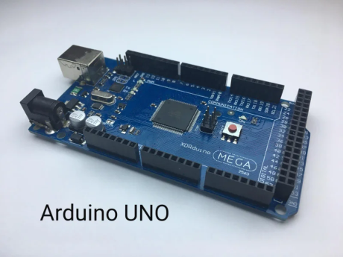

2.-Servo motor

A **servomotor** (or **servo motor**) is a [rotary actuator](https://en.wikipedia.org/wiki/Rotary_actuator) or [linear actuator](https://en.wikipedia.org/wiki/Linear_actuator) that allows for precise control of angular or linear position, velocity, and acceleration.[[1]](https://en.wikipedia.org/wiki/Servomotor#cite_note-1) It consists of a suitable motor coupled to a sensor for position feedback. It also requires a relatively sophisticated controller, often a dedicated module designed specifically for use with servomotors.

Servomotors are not a specific class of motor, although the term *servomotor* is often used to refer to a motor suitable for use in a [closed-loop control](https://en.wikipedia.org/wiki/Closed-loop_control) system.

Servomotors are used in applications such as [robotics](https://en.wikipedia.org/wiki/Robotics), [CNC machinery](https://en.wikipedia.org/wiki/CNC_machine), and [automated manufacturing](https://en.wikipedia.org/wiki/Automated_manufacturing).

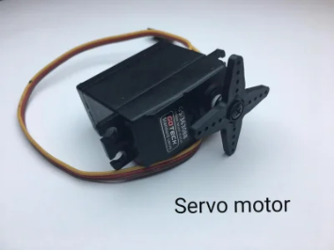

1. -PIR sensor

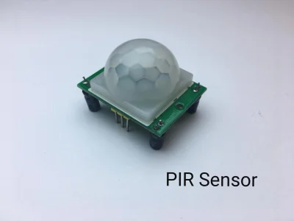

A **passive infrared sensor** (**PIR sensor**) is an electronic [sensor](https://en.wikipedia.org/wiki/Sensor) that measures [infrared](https://en.wikipedia.org/wiki/Infrared) (IR) light radiating from objects in its field of view. They are most often used in PIR-based [motion detectors](https://en.wikipedia.org/wiki/Motion_detector). PIR sensors are commonly used in security alarms and automatic lighting applications.

PIR sensors detect general movement, but do not give information on who or what moved. For that purpose, an [imaging IR sensor](https://en.wikipedia.org/wiki/Thermographic_camera) is required.

PIR sensors are commonly called simply "PIR", or sometimes "PID", for "passive infrared detector". The term *passive* refers to the fact that PIR devices do not radiate energy for detection purposes. They work entirely by detecting [infrared radiation](https://en.wikipedia.org/wiki/Infrared_radiation) (radiant heat) emitted by or reflected from objects.

1. -Bread board

A **breadboard**, **solderless breadboard**, or **protoboard** is a construction base used to build semi-permanent [prototypes](https://en.wikipedia.org/wiki/Electronic_prototype) of [electronic circuits](https://en.wikipedia.org/wiki/Electronic_circuit). Unlike a [perfboard](https://en.wikipedia.org/wiki/Perfboard) or [stripboard](https://en.wikipedia.org/wiki/Stripboard), breadboards do not require [soldering](https://en.wikipedia.org/wiki/Soldering) or destruction of tracks and are hence reusable. For this reason, breadboards are also popular with students and in technological education.

A variety of electronic systems may be prototyped by using breadboards, from small analog and digital circuits to complete [central processing units](https://en.wikipedia.org/wiki/Central_processing_unit) (CPUs).

Compared to more permanent circuit connection methods, modern breadboards have high parasitic capacitance, relatively high resistance, and less reliable connections, which are subject to jostle and physical degradation. Signaling is limited to about 10 MHz, and not everything works properly even well below that frequency.

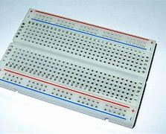

5, WIRES

A **jump wire** (also known as **jumper**, **jumper wire**, **DuPont wire**) is an [electrical wire](https://en.wikipedia.org/wiki/Electrical_wire), or group of them in a cable, with a connector or pin at each end (or sometimes without them – simply "tinned"), which is normally used to interconnect the components of a [breadboard](https://en.wikipedia.org/wiki/Breadboard) or other prototype or test circuit, internally or with other equipment or components, without soldering.[[1]](https://en.wikipedia.org/wiki/Jump_wire#cite_note-1)

Individual jump wires are fitted by inserting their "end connectors" into the slots provided in a breadboard, the [header connector](https://en.wikipedia.org/wiki/Pin_header) of a circuit board, or a piece of test equipment.

[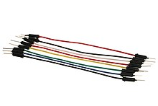](https://en.wikipedia.org/wiki/File:A_few_Jumper_Wires.jpg)

**WIRING OF SERVO MOTOR**

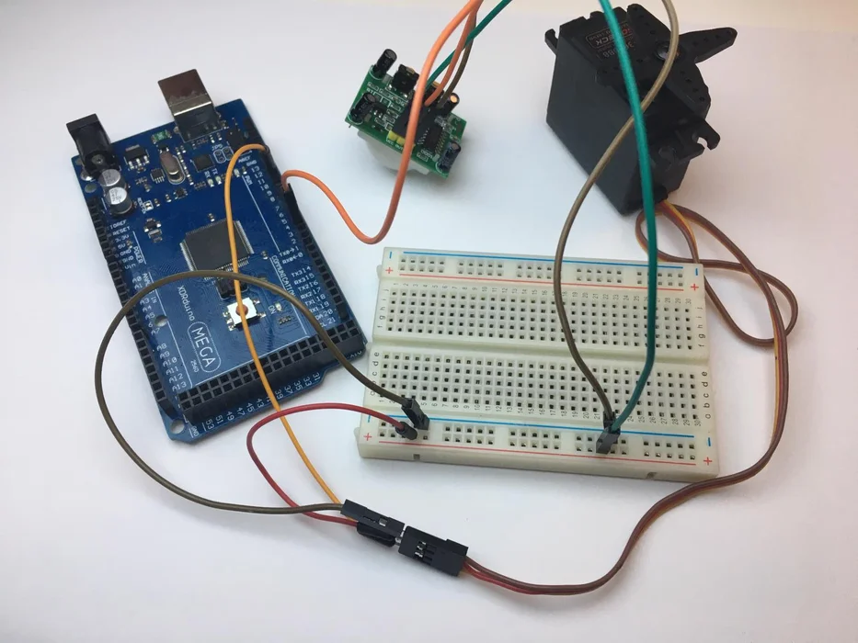

**SOURCE CODE/PROGRAMMING**

**#include <Servo.h>**

**// constants won't change**

**const int MOTION_SENSOR_PIN = 6; // Arduino pin connected to motion sensor's pinj**

**const int SERVO_PIN = 8; // Arduino pin connected to servo motor's pin**

**Servo servo;**

**int angle = 0; // the current angle of servo motor**

**int lastMotionState; // the previous state of motion sensor**

**int currentMotionState; // the current state of motion sensor**

**int buzzer=4;**

**void setup() {**

**Serial.begin(9600); // initialize serial**

**pinMode(MOTION_SENSOR_PIN, INPUT); // set arduino pin to input mode**

**servo.attach(SERVO_PIN); // attaches the servo on pin 9 to the servo object**

**pinMode(4,OUTPUT);**

**servo.write(angle);**

**currentMotionState = digitalRead(MOTION_SENSOR_PIN);**

**};**

**void loop() {**

**lastMotionState = currentMotionState; // save the last state**

**currentMotionState = digitalRead(MOTION_SENSOR_PIN); // read new state**

**if (currentMotionState == HIGH && lastMotionState == LOW) { // pin state change: LOW -> HIGH**

**Serial.println("Motion detected!");**

**servo.write(180);**

**digitalWrite(4,HIGH);**

**}**

**else**

**if (currentMotionState == LOW && lastMotionState == HIGH)**

**{**

**Serial.println("Motion stopped!");**

**servo.write(180);**

**digitalWrite(4,LOW);**

**}**

**}**

### Working Explanation

In the setup() function, the servo, and PIR sensor pins are declared as variables and the servo is attached to the appropriate pin using the servo.attach() function. The pinMode() function is used to set the PIR sensor as an input. And Serial.begin(9600) is used to start the serial communication.

In the loop() function, the state of the PIR sensor is read using the digitalRead() function and stored in a variable. An if statement is then used to check if the PIR sensor has detected motion. If the motion is detected, the servo.write() function is used to rotate the servo to a specific angle (e.g. 180 degrees). If no motion is detected, the servo is rotated back to its initial position (e.g. 0 degrees).

Finally, the state of the PIR sensor and the angle of the servo are printed to the serial monitor using the Serial.println() function. This allows the user to see the status of the PIR sensor and the servo motor in real time

**CIRCUIT DIAGRAM**

### 

When the pir sensor detects any motion of a person , its data output pin will become HIGH,

As this pin is connected to the Arduino , it will detect this HIGH signal and understand that there is person approaching the door.

## Applications

* Surveillance systems
* Robotics
* Automatic doors
* Security systems
* Automated curtains and blinds
* Automated pet feeders
* Smart home automation
* Automated plant watering systems

## Conclusion.

We hope you have found this Motion Sensor Servo Motor Circuit very useful.

So, this Automatic open door is very important to everyone and it's popular choice for business because they allow customers to enter and exit easily without the need to manually open and close the door.

They also provide touchless option which has become increasingly important in light of COVID-19 pandemic.

THIS PROJECT DONE BY:

Delphine NZAMBAZAMRIYA.